
5th Semester - UE18CS305 – Operating Systems Laboratory

WEEK 3: Process Creation and Termination Date: 11/09/2020

OBJECTIVE:
Understanding Parent-Child Process relationship and the working of fork(), exec() and wait() system calls

- STUDENTS ARE ADVISED TO READ THE TUTORIAL PROVIDED IN THE END OF THIS DOCUMENT BEFORE WORKING ON THE ACTUAL PROGRAMS.
- STUDENTS ARE REQUIRED TO PROVIDE PROOF OF CONDUCTION (SEE SUBMISSION BELOW) ONLY FOR THE ACTUAL PROGRAMS. SO THIS TIME THERE IS NO NEED TO SEND SCREENSHOTS FOR THE PRACTICE PROGRAMS INCLUDED IN THE TUTORIAL.
- ALSO, ANSWER 5 QUESTIONS ASKED AT THE END OF THIS DOCUMENT.

SUBMISSION:
- All the source code files for the actual programs should be uploaded to EDMODO separately in WORD or ZIP FORMAT.
- All the screenshots clearly showing the directory name as SRN_NAME_WEEK3, all the output, results for the actual programs and the answers to 5 QUESTIONS should be uploaded to EDMODO in a SEPARATE FILE (Word or PDF format only, Do NOT zip this file). So, even the answers to the questions asked at the end of this document should go into the same file.

Students should keep these TWO deliverables (i.e. 1 & 2 above) separate and NOT zip all the files together in order to facilitate quick, timely and effective evaluation.

Contact your respective Lab faculty for any questions or clarifications needed.

DUE DATE FOR SUBMISSION: 17/09/2020 11:59 PM

Department of Computer Science and Engineering Page 1 Aug – Dec 2020
PROGRAMS FOR EXECUTION AND SUBMISSION:
- The Fibonacci sequence is the series of numbers 0, 1, 1, 2, 3, 5, 8, ... Write a C program using the fork() system call that generates the Fibonacci sequence in the child process. The number of the sequence should be provided in the command line. For example, if 5 is provided as an input to the program, the first five numbers in the Fibonacci sequence should be output by the child process.
- Write a C program that uses the child to compute partial sums and parent to compute the partial products of an array of integers. Both child and parent should print the respective total sum and product values. Use an array with a minimum of 5 elements.
- Write a C program to demonstrate the use of fork(), exec() and wait() all in one program. Use any one of the family of exec system calls such as execl() or execvp().
Example: If the input/argument to the program is one of these
ls, ls –l, find, <executable_program>
then your program should display the output of the same command (like the output of “ls –l” command) or the executable_program that was passed as an argument.

Answer the following questions and submit your answers as specified in Submission #2:
- What is the role of the init process on UNIX and Linux systems in regard to process termination?
- What is a subreaper process?
- What causes a defunct process on the Linux system and how can you avoid it?
- How can you identify zombie processes on the Linux system?
- What does child process inherit from its parent?

References: https://www.geeksforgeeks.org/exec-family-of-functions-in-c
‘Man’ pages of individual commands on Linux system

Department of Computer Science and Engineering Page 2 Aug – Dec 2020
TUTORIAL

The fork() System Call
System call fork() is used to create processes. It takes no arguments and returns a process ID. The purpose of fork() is to create a new process, which becomes the child process of the caller. After a new child process is created, both processes will execute the next instruction following the fork() system call. Therefore, we have to distinguish the parent from the child. This can be done by testing the returned value of fork():
- If fork() returns a negative value, the creation of a child process was unsuccessful.
- fork() returns a zero to the newly created child process.
- fork() returns a positive value, the process ID of the child process, to the parent. The returned process ID is of type pid_t defined in sys/types.h. Normally, the process ID is an integer. Moreover, a process can use function getpid() to retrieve the process ID assigned to this process.
Therefore, after the system call to fork(), a simple test can tell which process is the child. Please note that Unix/Linux will make an exact copy of the parent's address space and give it to the child. Therefore, the parent and child processes have separate address spaces.
Let us take an example to make the above points clear. This example does not distinguish parent and the child processes.
#include <stdio.h>
#include <string.h>
#include <sys/types.h>

#define MAX_COUNT 200
#define BUF_SIZE 100

void main(void)
{
pid_t pid;
int i;
char buf[BUF_SIZE];

fork();
pid = getpid();
for (i = 1; i <= MAX_COUNT; i++) {
sprintf(buf, "This line is from pid %d, value = %d\n", pid, i);
write(1, buf, strlen(buf));
}
}
Department of Computer Science and Engineering Page 3 Aug – Dec 2020
Suppose the above program executes up to the point of the call to fork() (marked in red color):
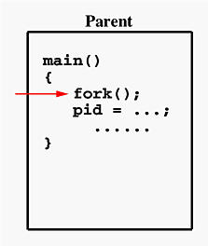
If the call to fork() is executed successfully, Unix will
- make two identical copies of address spaces, one for the parent and the other for the child.
- Both processes will start their execution at the next statement following the fork() call. In this case, both processes will start their execution at the assignment statement as shown below:
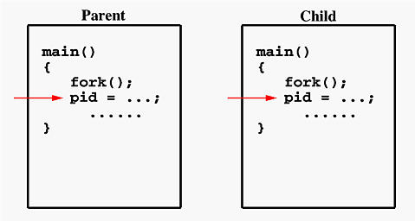
Both processes start their execution right after the system call fork(). Since both processes have identical but separate address spaces, those variables initialized before the fork() call have the same values in both address spaces. Since every process has its own address space, any modifications will be independent of the others. In other words, if the parent changes the value of its variable, the modification will only affect the variable in the parent process's address space. Other address spaces created by fork() calls will not be affected even though they have identical variable names.
Department of Computer Science and Engineering Page 4 Aug – Dec 2020
What is the reason of using write rather than printf? It is because printf() is "buffered," meaning printf() will group the output of a process together. While buffering the output for the parent process, the child may also use printf to print out some information, which will also be buffered. As a result, since the output will not be sent to screen immediately, you may not get the right order of the expected result. Worse, the output from the two processes may be mixed up in strange ways. To overcome this problem, you may consider using the "unbuffered" write.
If you run this program, you might see the following (but with different PIDs as per your system) on the screen:
................
This line is from pid 3456, value 13
This line is from pid 3456, value 14
................
This line is from pid 3456, value 20
This line is from pid 4617, value 100
This line is from pid 4617, value 101
................
This line is from pid 3456, value 21
This line is from pid 3456, value 22
................
Process ID 3456 may be the one assigned to the parent or the child. Due to the fact that these processes are run concurrently, their output lines are intermixed in a rather unpredictable way. Moreover, the order of these lines are determined by the CPU scheduler. Hence, if you run this program again, you may get a totally different result.
Consider another simple example, which distinguishes the parent from the child.
#include <stdio.h>
#include <sys/types.h>

#define MAX_COUNT 200

void ChildProcess(void); /* child process prototype */
void ParentProcess(void); /* parent process prototype */

void main(void)
{
pid_t pid;

pid = fork();
if (pid == 0)
ChildProcess();
else
ParentProcess();
}

Department of Computer Science and Engineering Page 5 Aug – Dec 2020

void ChildProcess(void)
{
int i;

for (i = 1; i <= MAX_COUNT; i++)
printf(" This line is from child, value = %d\n", i);
printf(" *** Child process is done ***\n");
}

void ParentProcess(void)
{
int i;

for (i = 1; i <= MAX_COUNT; i++)
printf("This line is from parent, value = %d\n", i);
printf("*** Parent is done ***\n");
}
In this program, both processes print lines that indicate (1) whether the line is printed by the child or by the parent process, and (2) the value of variable i. For simplicity, printf() is used.
When the main program executes fork(), an identical copy of its address space, including the program and all data, is created. System call fork() returns the child process ID to the parent and returns 0 to the child process. The following figure shows that in both address spaces there is a variable pid. The one in the parent receives the child's process ID 3456 and the one in the child receives 0.
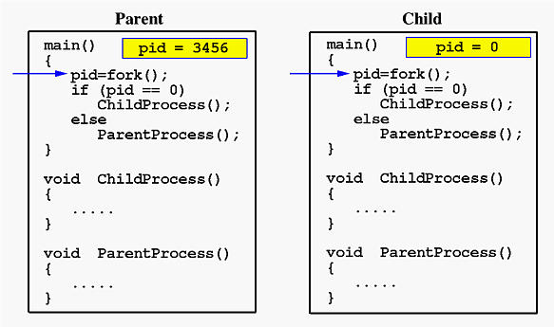
Now both programs (i.e., the parent and child) will execute independent of each other starting at the next statement:
Department of Computer Science and Engineering Page 6 Aug – Dec 2020

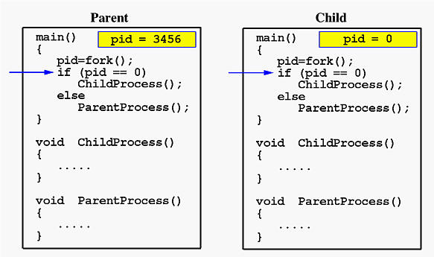
In the parent, since pid is non-zero, it calls function ParentProcess(). On the other hand, the child has a zero pid and calls ChildProcess() as shown below:
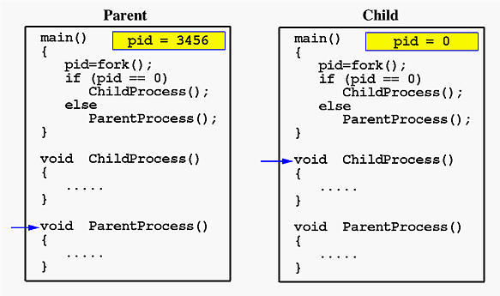
Due to the fact that the CPU scheduler will assign a time quantum to each process, the parent or the child process will run for some time before the control is switched to the other and the running process will print some lines before you can see any line printed by the other process. Therefore, the value of MAX_COUNT should be large enough so that both processes will run for at least two or more time quanta. If the value of MAX_COUNT is so small that a process can finish in one time quantum, you will see two groups of lines, each of which contains all lines printed by the same process.

Department of Computer Science and Engineering Page 7 Aug – Dec 2020

The exec() system call

Department of Computer Science and Engineering Page 8 Aug – Dec 2020

Department of Computer Science and Engineering Page 9 Aug – Dec 2020

EXAMPLE 1:
You can compile “gcc forksleep.c” without using any arguments shown below and notice the differences

Department of Computer Science and Engineering Page 10 Aug – Dec 2020

EXAMPLE 2:
Example.c
Hello.c

Department of Computer Science and Engineering Page 11 Aug – Dec 2020

